Instructions Regarding Completion and Review of
American Indian/Alaska Native Indian Child Welfare Act (ICWA)
Assessment Form (JDF 567) or Declaration of Non-Indian Heritage Form (JDF 568)

Caseworker's Name:

Court Case Number:

Name of Biological Mother: | Name of Biological Father:
Date form initially completed:

Please meet with family members or other persons who may have information
regarding the child's tribal status and ancestry.

Return the completed form to the County/City Attorney's Office within five days.

- The information requested is necessary to determine if the Indian Child Welfare Act (ICWA) applies to the case involving the child(ren). In a dependency and neglect case, at the time of the initial intake and throughout the case, the caseworker must ask family members or others involved with the child(ren) if the child and the child's relatives have any American Indian or Alaska Native ancestry. The family tree charts on pages 2 and 3 may be helpful in collecting information.

- Upon gathering information, if it is determined that the child does appear to be a member of a tribe or is not believed to be eligible for membership in one or more tribes, complete the Declaration of Non-Indian Heritage form - JDF 568. If at any time new information is obtained that the may change the status of the child, complete the assessment form – JDF 567.

- The assessment form - JDF 567 must be completed by the caseworker after gathering information from a knowledgeable parent, guardian, Indian custodian or other family member on behalf of the child whose tribal status is in question. Contact your supervisor or the Court/City Attorney's office if you have any questions regarding proper procedure for ICWA compliance.

- Please fill out either JDF 567 or JDF 568 as accurately and as thoroughly as possible. The information will influence the entire course of action and outcome in the case. Once completed, send to County/City Attorney's office without delay.

- A copy of the assessment form - JDF 567 will be sent to the identified tribes, so please make sure that it can be easily read.

- Please be sure that both you and the person giving the information contained in the form sign and date the completed form.

- Under Colorado law, there is a continuing duty to inquire regarding a child's Indian status. Periodically, throughout the case proceedings, review the contents of the form with the child's family members to ensure the information is complete and up to date. It is critical that the form be reviewed with the child's family prior to a motion to terminate parental rights being filed. The attached flow chart indicates recommended times in a dependency and neglect case that the form should be reviewed and updated

- After each review of the form, please be sure to write your name and the date of the review on the form.

- When new information regarding the child's tribal status or ancestry is received please update the information to the assessment form - JDF 567 and notify the City/County Attorney's office.

American Indian/Alaska Native ICWA Assessment Form Family Chart
(Child's Mother's Side)
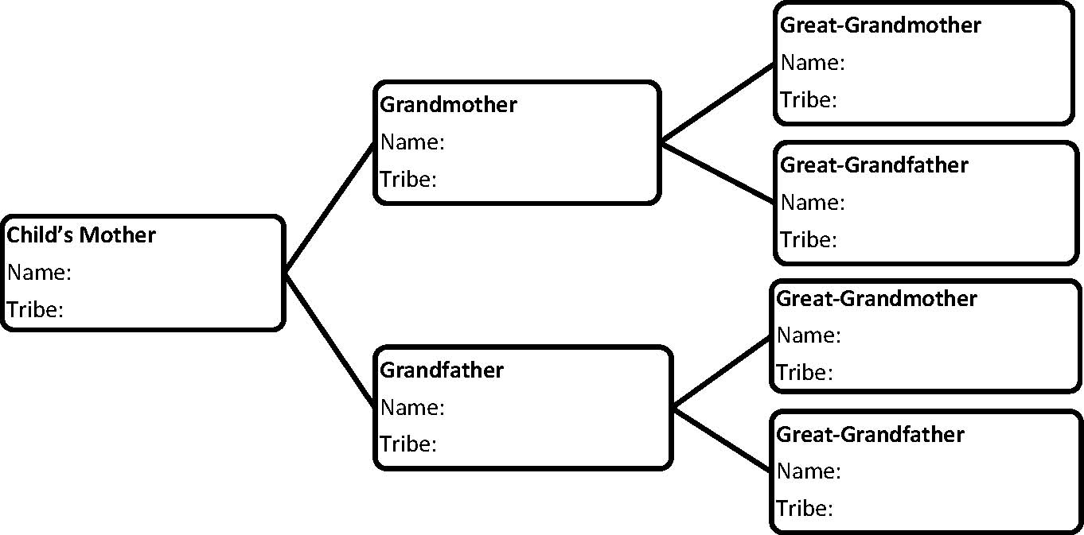
Case No. _______________ Name of Child: ______________________________

American Indian/Alaska Native ICWA Assessment Form Family Chart
(Child's Father's Side)

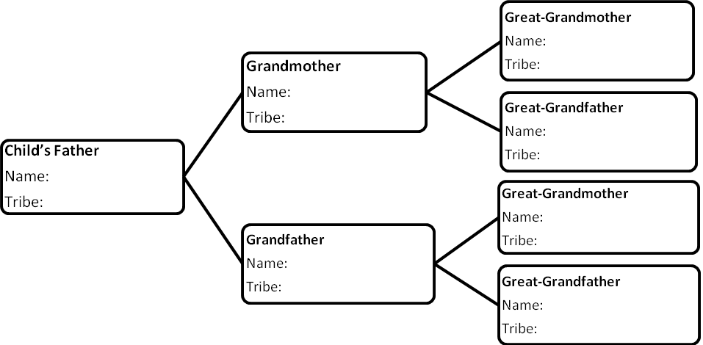

Case No. _______________ Name of Child: ______________________________

