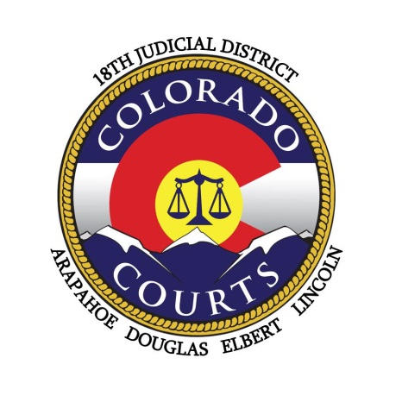**Eighteenth Judicial District**

**Arapahoe, Douglas, Elbert & Lincoln Counties**

**EMERGENCY ELECTION MATTERS**

**November 5, 2024**

If you have emergency election matters that need to be heard after hours, please contact the Clerk of Court for your County at the following number:

**Arapahoe-** 303-645-6789

**Douglas-** 720-437-6211

**Elbert-**303-621-3225

**Lincoln-**719-760-0652

They will then contact the Election Night Duty Judge to determine the appropriate course of action.